HPC LABORATORY
Experiment No. 8
Comparative Study of OpenMP and MPI for Parallel Applications

Submitted by
Yash Vilas Jamdade
PRN: 23510109

1. Aim
To implement selected computationally intensive applications using both OpenMP and MPI, and experimentally compare their performance, scalability, memory model, communication overhead, and suitability for different HPC workloads.

2. Learning Focus
Concept | OpenMP | MPI
Memory model | Shared memory | Distributed memory
Parallel unit | Thread | Process
Communication | Shared variables | Message passing
Data sharing | Implicit/shared | Explicit
Scalability | Within shared-memory system | Across multiple nodes
Synchronization | Critical, barrier, atomic, reduction | Send/Receive and collective communication
Programming complexity | Generally lower | Generally higher
Multi-node execution | Limited | Well suited

3. Experimental Setup
Parameter | Observed setup
Operating System | Ubuntu 22.04.5 LTS
CPU | 12th Gen Intel Core i5-12450H
CPU logical processors | 12
Physical cores | 8
Threads per core | 2
RAM | 15 GiB
Compiler | G++ 11.4.0
MPI | Open MPI 4.1.2
OpenMP maximum threads | 12
All programs were compiled with optimization level -O2. OpenMP programs were compiled with -fopenmp and MPI programs with mpic++.

4. Task 1 – Matrix–Matrix Multiplication
The matrix multiplication experiment used 500×500, 1000×1000, and 2000×2000 matrices. The same deterministic input generation was used across the sequential, OpenMP, and MPI implementations. MPI used row-wise decomposition, broadcast of matrix B, and collective distribution/gathering of rows.

4.1 Sequential Results
Matrix Size | Execution Time (s) | Checksum
500×500 | 0.055338 | 306281250000
1000×1000 | 0.378568 | 2450250000000
2000×2000 | 4.440413 | 19602000000000

4.2 OpenMP Results
Matrix Size | Threads | Time (s) | Speedup | Efficiency
500×500 | 2 | 0.032643 | 1.695 | 0.848
500×500 | 4 | 0.021585 | 2.564 | 0.641
500×500 | 8 | 0.012647 | 4.376 | 0.547
500×500 | 12 | 0.009053 | 6.113 | 0.509
1000×1000 | 2 | 0.219119 | 1.728 | 0.864
1000×1000 | 4 | 0.117414 | 3.224 | 0.806
1000×1000 | 8 | 0.099908 | 3.789 | 0.474
1000×1000 | 12 | 0.074122 | 5.107 | 0.426
2000×2000 | 2 | 2.469897 | 1.798 | 0.899
2000×2000 | 4 | 1.325616 | 3.350 | 0.837
2000×2000 | 8 | 0.914328 | 4.856 | 0.607
2000×2000 | 12 | 0.721450 | 6.155 | 0.513

4.3 MPI Results
Matrix Size | Processes | Time (s) | Speedup | Efficiency
500×500 | 2 | 0.021894 | 2.528 | 1.264
500×500 | 4 | 0.014675 | 3.771 | 0.943
500×500 | 8 | 0.011898 | 4.651 | 0.581
1000×1000 | 2 | 0.246340 | 1.537 | 0.768
1000×1000 | 4 | 0.188707 | 2.006 | 0.502
1000×1000 | 8 | 0.180343 | 2.099 | 0.262
2000×2000 | 2 | 2.254342 | 1.970 | 0.985
2000×2000 | 4 | 1.608753 | 2.760 | 0.690
2000×2000 | 8 | 1.463294 | 3.035 | 0.379

4.4 Matrix Multiplication Graphs
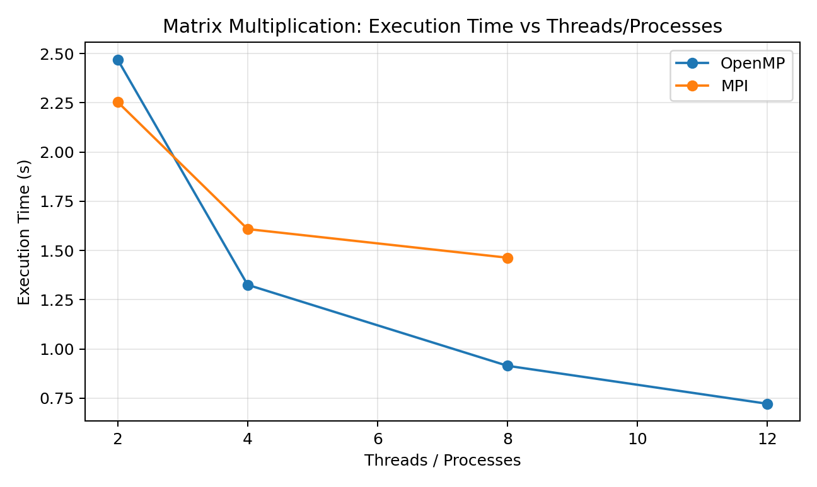
Figure 1. Execution time versus threads/processes for 2000×2000 matrix multiplication.
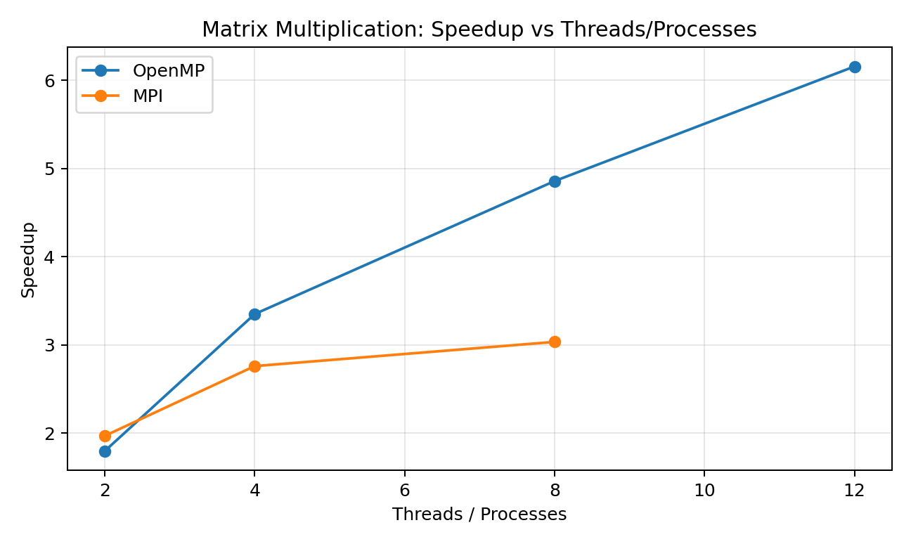
Figure 2. Speedup versus threads/processes for 2000×2000 matrix multiplication.
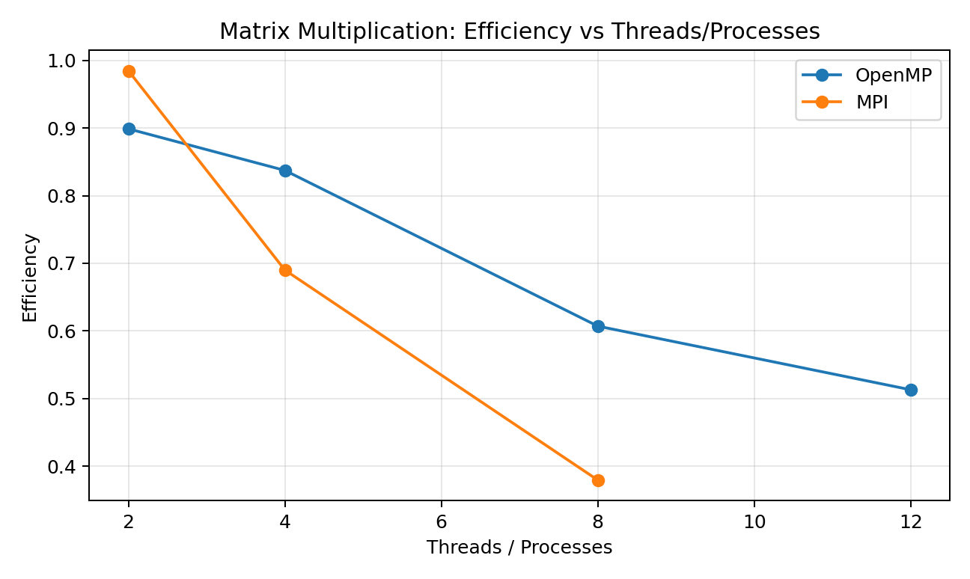
Figure 3. Efficiency versus threads/processes for 2000×2000 matrix multiplication.
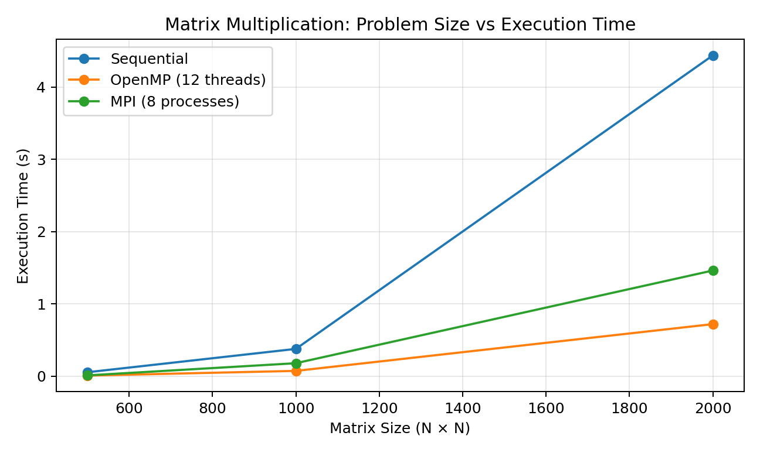
Figure 4. Problem size versus execution time.

4.5 Matrix Multiplication Analysis
OpenMP showed strong improvement as the number of threads increased. For the 2000×2000 case, the measured time decreased from 2.469897 s with 2 threads to 0.721450 s with 12 threads. MPI also improved from 2.254342 s with 2 processes to 1.463294 s with 8 processes, but its scaling was weaker than OpenMP for the larger configurations.
The 500×500 MPI result with 2 processes produced an observed efficiency greater than 1 because the measured MPI time was lower than the sequential baseline. This is a measured result and was retained rather than artificially adjusted.
The experiment demonstrates that larger computational workloads provide more opportunity for parallel execution, while communication and parallel overhead can limit scaling.

5. Task 2 – 2D Convolution
A 3×3 all-ones convolution kernel was applied to 1000×1000, 2000×2000, and 4000×4000 inputs. The MPI implementation used row-wise domain decomposition and exchanged neighboring boundary rows (halo data) between adjacent processes.

5.1 Sequential Results
Input Size | Execution Time (s) | Checksum
1000×1000 | 0.003164 | 443720264
2000×2000 | 0.012203 | 1778438264
4000×4000 | 0.049227 | 7120874264

5.2 OpenMP Scheduling Results
Schedule | Threads | Input Size | Time (s)
static | 2 | 1000×1000 | 0.001776
static | 2 | 2000×2000 | 0.006155
static | 2 | 4000×4000 | 0.023804
static | 4 | 1000×1000 | 0.002380
static | 4 | 2000×2000 | 0.003455
static | 4 | 4000×4000 | 0.013208
static | 8 | 1000×1000 | 0.001590
static | 8 | 2000×2000 | 0.004654
static | 8 | 4000×4000 | 0.018476
static | 12 | 1000×1000 | 0.001223
static | 12 | 2000×2000 | 0.003642
static | 12 | 4000×4000 | 0.014255
dynamic | 2 | 1000×1000 | 0.001744
dynamic | 2 | 2000×2000 | 0.006073
dynamic | 2 | 4000×4000 | 0.023810
dynamic | 4 | 1000×1000 | 0.001397
dynamic | 4 | 2000×2000 | 0.004536
dynamic | 4 | 4000×4000 | 0.015353
dynamic | 8 | 1000×1000 | 0.000929
dynamic | 8 | 2000×2000 | 0.003175
dynamic | 8 | 4000×4000 | 0.011335
dynamic | 12 | 1000×1000 | 0.001098
dynamic | 12 | 2000×2000 | 0.003793
dynamic | 12 | 4000×4000 | 0.014188
guided | 2 | 1000×1000 | 0.002382
guided | 2 | 2000×2000 | 0.009958
guided | 2 | 4000×4000 | 0.025843
guided | 4 | 1000×1000 | 0.001810
guided | 4 | 2000×2000 | 0.006489
guided | 4 | 4000×4000 | 0.012990
guided | 8 | 1000×1000 | 0.001047
guided | 8 | 2000×2000 | 0.003121
guided | 8 | 4000×4000 | 0.016104
guided | 12 | 1000×1000 | 0.003322
guided | 12 | 2000×2000 | 0.002796
guided | 12 | 4000×4000 | 0.010537

5.3 Best Observed OpenMP Configurations
Input Size | Schedule | Threads | Time (s) | Speedup | Efficiency
1000×1000 | dynamic | 8 | 0.000929 | 3.406 | 0.426
2000×2000 | guided | 12 | 0.002796 | 4.364 | 0.364
4000×4000 | guided | 12 | 0.010537 | 4.672 | 0.389

5.4 MPI Results
Input Size | Processes | Time (s) | Speedup | Efficiency
1000×1000 | 2 | 0.005503 | 0.575 | 0.287
1000×1000 | 4 | 0.005103 | 0.620 | 0.155
1000×1000 | 8 | 0.006904 | 0.458 | 0.057
2000×2000 | 2 | 0.021829 | 0.559 | 0.280
2000×2000 | 4 | 0.020458 | 0.596 | 0.149
2000×2000 | 8 | 0.028466 | 0.429 | 0.054
4000×4000 | 2 | 0.084686 | 0.581 | 0.291
4000×4000 | 4 | 0.078983 | 0.623 | 0.156
4000×4000 | 8 | 0.106682 | 0.461 | 0.058

5.5 2D Convolution Graphs
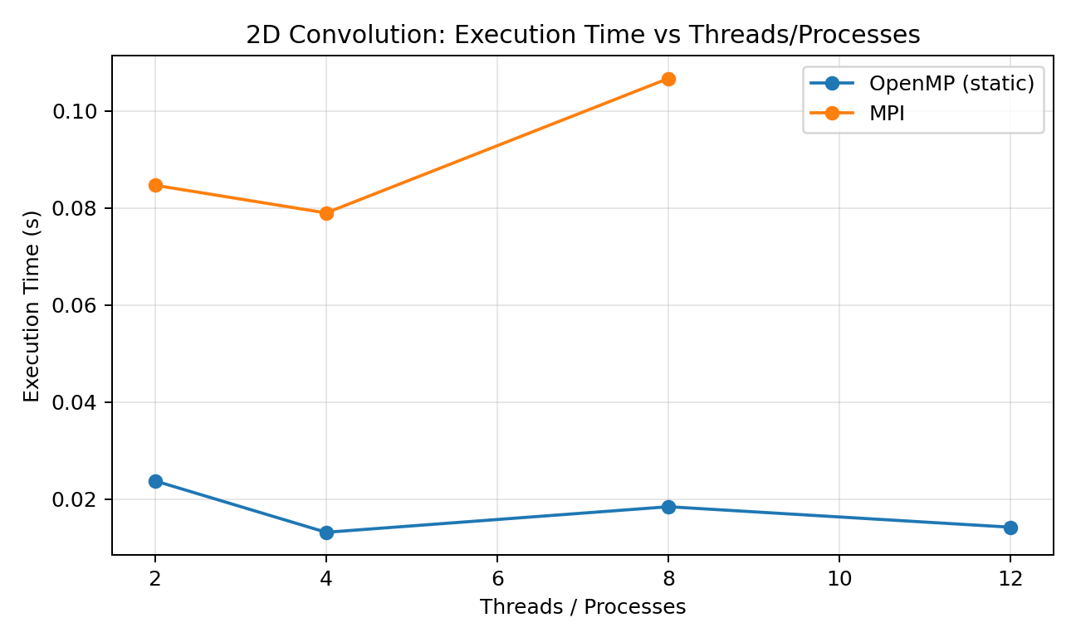
Figure 5. Execution time versus threads/processes for 4000×4000 convolution; OpenMP uses static scheduling.
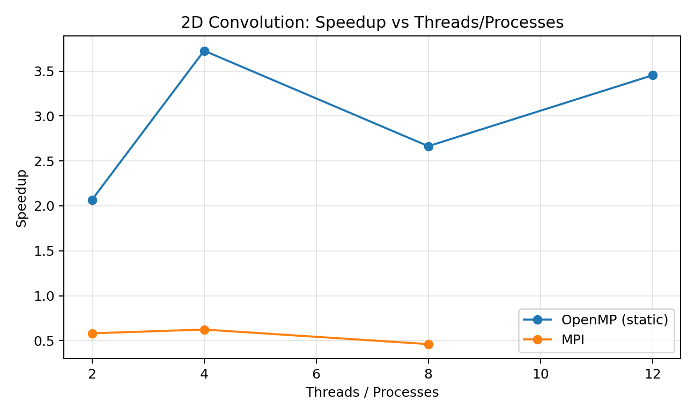
Figure 6. Speedup versus threads/processes for 4000×4000 convolution; OpenMP uses static scheduling.
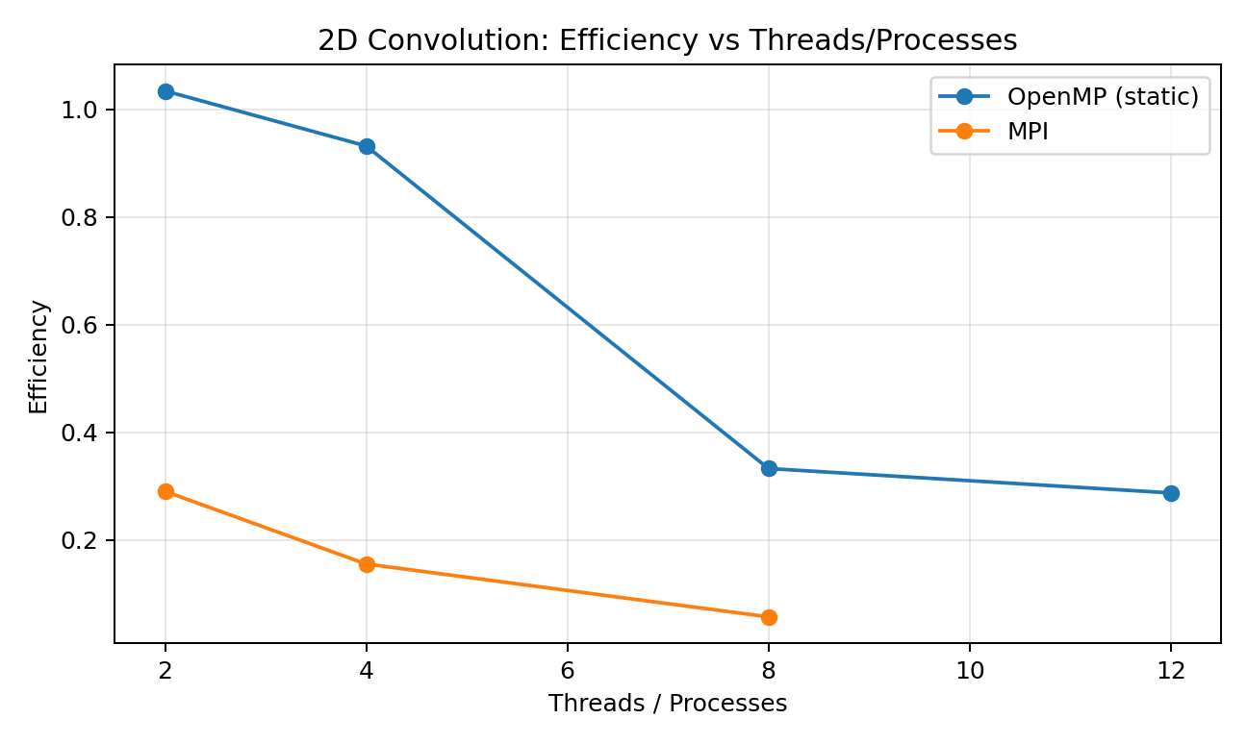
Figure 7. Efficiency versus threads/processes for 4000×4000 convolution; OpenMP uses static scheduling.
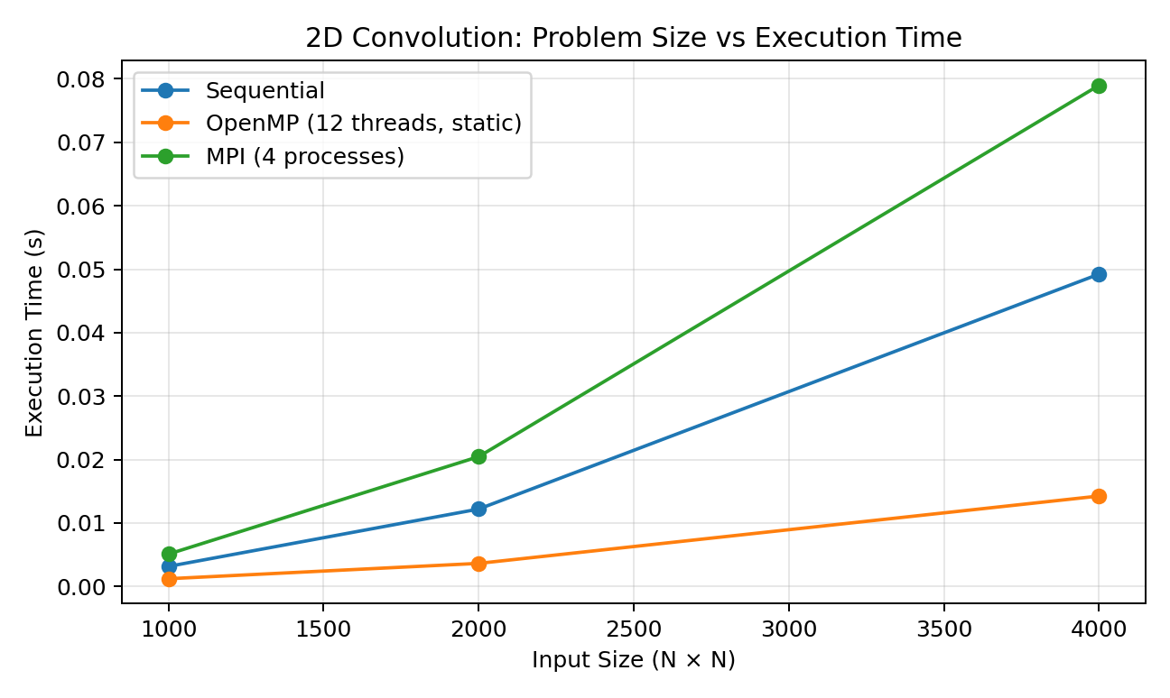
Figure 8. Problem size versus execution time.

5.6 Scheduling Analysis
The three OpenMP scheduling strategies produced different measured times. Dynamic scheduling was fastest for 1000×1000 at 8 threads (0.000929 s). Guided scheduling was fastest for 2000×2000 at 12 threads (0.002796 s) and for 4000×4000 at 12 threads (0.010537 s). Static scheduling also performed competitively. These results show that scheduling overhead and workload distribution can affect performance even when the computational work is regular.

5.7 MPI Halo Analysis
2D convolution requires neighboring input values. Therefore, when rows are distributed among MPI processes, a process may need the row immediately above or below its local domain. The MPI implementation exchanged these boundary rows with neighboring processes using MPI_Sendrecv. The resulting checksums matched the sequential and OpenMP checksums for all tested sizes, verifying the boundary-exchange implementation.

6. Strong Comparative Analysis
Application | Sequential | OpenMP observation | MPI observation
Matrix multiplication | Baseline | Strong speedup up to 6.155× at 12 threads for 2000×2000 | Speedup up to 3.035× at 8 processes for 2000×2000
2D convolution | Very fast sequential baseline | Strong improvement; scheduling affects measured performance | Communication/halo overhead dominated; MPI was slower than sequential on this single shared-memory machine
On the tested single-node shared-memory system, OpenMP generally provided the better performance for these workloads. MPI incurred additional communication and data-distribution overhead. This does not imply MPI is generally inferior: its major advantage is the ability to scale across multiple nodes.

7. Architecture and Memory Analysis
Feature | OpenMP | MPI
Memory model | Shared memory | Distributed memory
Execution unit | Thread | Process
Communication mechanism | Shared variables / synchronization | Explicit message passing
Synchronization | Critical, barrier, atomic, reduction | Send/Receive and collective operations
Data distribution | Threads operate on shared data | Data must be explicitly distributed
Communication overhead | Low on shared-memory system | Higher due to message passing
Scalability | Within shared-memory system | Across multiple nodes
Multi-node suitability | Limited | Well suited
Programming complexity | Generally lower | Generally higher

8. Hybrid MPI + OpenMP Design
For a cluster containing 4 compute nodes with 8 CPU cores per node, a conceptual hybrid design can use one MPI process per node and eight OpenMP threads inside each process. MPI distributes large matrix regions across nodes, while OpenMP parallelizes computation within each node.
This approach can reduce the number of MPI processes and therefore reduce inter-process communication while still using all CPU cores. Challenges include process/thread affinity, memory placement, synchronization, load balancing, and avoiding oversubscription.

9. AI/HPC Case Study – Image Processing
Image processing is a suitable workload for both OpenMP and MPI because large images can be represented as two-dimensional grids and many operations apply the same computation independently to many pixels. Examples include convolution, filtering, edge detection, denoising, and feature preprocessing. The amount of data can range from a single large image to batches of high-resolution images or scientific image volumes.
On a shared-memory multicore system, OpenMP is appropriate because threads can directly access the common image data. An outer image-row loop can be parallelized, allowing different threads to process different rows. Scheduling can be selected according to the workload. Static scheduling is attractive for regular convolution, while dynamic or guided scheduling can be evaluated when the amount of work varies.
MPI becomes useful when the image data is too large for one node or when a collection of nodes is available. The image can be divided into row-wise or block-wise domains. For convolution, neighboring domains require boundary or halo information, so MPI processes must exchange boundary rows or columns before computing border pixels. Communication frequency and the amount of halo data influence scalability.
A hybrid MPI + OpenMP approach can combine both advantages. MPI can distribute large image regions among nodes, while OpenMP uses all CPU cores inside each node. This can reduce the number of MPI processes and the volume of inter-process communication while maintaining high intra-node parallelism. The appropriate model therefore depends on image size, memory capacity, network cost, computational intensity, and available hardware.

10. Reflection Questions
1. Why can the same algorithm be implemented using both OpenMP and MPI?
The computational algorithm can remain the same while the parallel execution model changes. OpenMP uses shared-memory threads, whereas MPI uses distributed processes and explicit communication.
2. What is the fundamental difference between OpenMP threads and MPI processes?
OpenMP threads share the memory of a process; MPI processes have separate address spaces and communicate through messages.
3. Which model requires explicit communication?
MPI requires explicit communication between processes.
4. Why does MPI require data distribution?
Each process has its own address space, so the required portion of the input data must be distributed to it.
5. Why does OpenMP generally have lower communication overhead on a single shared-memory machine?
Threads can access shared memory directly, avoiding explicit message passing between separate address spaces.
6. Why can MPI scale to multiple nodes?
MPI processes can execute on different nodes and communicate over the network.
7. Why is matrix multiplication a good candidate for both OpenMP and MPI?
Its computation contains a large number of independent arithmetic operations and can be divided among threads or processes.
8. Why does 2D convolution require special consideration for boundary data in MPI?
A convolution output uses neighboring input elements, so a process may need rows belonging to a neighboring process.
9. What is a halo or ghost region?
It is extra boundary data copied or exchanged from neighboring domains so local computation can access required neighboring values.
10. Why might increasing threads/processes eventually stop improving performance?
Parallel overhead, communication, synchronization, memory bandwidth, and limited available work can reduce the benefit of additional parallel workers.
11. How does problem size affect parallel speedup?
Larger problems generally provide more computation to amortize parallel overhead, although scaling is still limited by architecture and communication.
12. What factors should be considered before selecting OpenMP or MPI?
Memory architecture, number of nodes, communication cost, problem decomposition, scalability requirements, workload characteristics, and programming complexity.

11. Answers Based on Experimental Observations
Which programming model was easier to implement and why?
OpenMP was easier for the shared-memory machine because parallelization mainly required adding OpenMP directives and controlling the number of threads. MPI required explicit data distribution, collective communication, and boundary exchange.
What was the major performance difference between OpenMP and MPI?
For matrix multiplication, OpenMP achieved stronger scaling at higher parallelism. For 2D convolution, MPI was slower than the sequential baseline in the measured single-node experiments, while OpenMP provided substantial speedup.
How did the problem size affect the comparison?
Increasing matrix size increased the available computational work and made parallel execution increasingly beneficial for matrix multiplication. Convolution also scaled in absolute execution time, while communication overhead remained significant for MPI.
What communication overhead did you observe in MPI?
MPI convolution remained slower than the sequential baseline and became slower again at 8 processes, indicating that process communication, data distribution, and halo exchange contributed significant overhead on the tested machine.
How did increasing the number of threads/processes affect performance?
OpenMP matrix multiplication generally improved as threads increased. MPI matrix multiplication improved from 2 to 8 processes, but with diminishing gains. MPI convolution was fastest at 4 processes rather than 8.
Did the fastest implementation remain the same for both applications?
No. OpenMP was clearly effective for both applications on this machine, but the detailed best configuration differed because convolution was sensitive to scheduling and MPI communication overhead.
What did this experiment teach about selecting a parallel programming model?
The best model depends on architecture and workload. Shared-memory computation on one multicore machine can favor OpenMP, while MPI is essential when computation must span multiple nodes.
In a real HPC cluster, would you use OpenMP, MPI, or a combination?
For a multi-node cluster, MPI or hybrid MPI + OpenMP would be appropriate. MPI can distribute work across nodes and OpenMP can exploit cores within each node.

12. Conclusion
This experiment compared OpenMP and MPI using matrix multiplication and 2D convolution. The implementations used the same computational workloads and their checksums matched, providing a correctness check. On the tested 8-core/12-thread single-node system, OpenMP generally achieved better performance and scaling because threads share memory and avoid explicit inter-process communication. MPI successfully implemented row-wise decomposition and, for convolution, halo exchange, but its communication overhead was significant on this single-node setup. The experiment demonstrates that OpenMP is well suited to shared-memory multicore systems, MPI is designed for distributed-memory and multi-node execution, and hybrid MPI + OpenMP can combine both models for larger HPC workloads.

13. Source Code Files
• matrix_sequential.cpp
• matrix_openmp.cpp
• matrix_mpi.cpp
• convolution_sequential.cpp
• convolution_openmp.cpp
• convolution_mpi.cpp
The source files listed above were implemented and executed during the experiment.

